**Testing**

|  |  |  |  |  |
| --- | --- | --- | --- | --- |
| Test No. | Test Data/ Action | Reason/ Explanation | Expected Result | Actual Result |
| 1 | Starting the program. | To see that no errors have been run into when dynamically creating the objects. | The program shows a message saying the program has started. The | The program starts up correctly with no errors. Displaying the correct message, see ***figure 1.*** |
| 2 | Clicking the set Max Data button with valid integer input, which was 5. | To see if the user can choose the amount of stocks that they would like to have in the program. Sets the array length for subsequent arrays and uses this number in subsequent algorithm. | The array length is set and a message is outputted to allow the user to know this has been done, successfully. | The program outputs the text “Yes” to the edit box where the let the user that the maximum stock amount for the program has been set, see ***figure 2,*** you can also see evidence of the max data of stocks allowed in ***figure 3.*** |
| 2a | Clicking the set Max Data button with invalid string input, which is ‘Test’. | To stop the program from crashing when the user enters an invalid input, instead it should explain the reason why the input was invalid so that the user can enter a corrected version. | The program shows a message that is helpful to the user allowing them to edit their choice and input it in their next input. | The program shows a message that is helpful to the user allowing them to edit their choice and input it in their next input, for details see ***figure 12***. Successful test. |
| 2b | Clicking the set max data button, with an invalid integer as it is less than 5, ‘4’. | A minimum max data value set. A sensible value as, a user could have less than 5 however stops a user trying to enter a max data of less than 1 as it isn’t possible. 5 was seen as a reasonable minimum which was chosen by myself. | The program should change the value that was entered to the minimum amount stocks that can be entered which is 5, outputting it as text to the edit box where the invalid number was entered. | The program should change the value that was entered to the minimum amount stocks that can be entered which is 5, outputting it as text to the edit box where the invalid number was entered, for details see ***figure 13.*** Successful test. |
| 3 | Clicking the restart button to reset all variables and objects. | To see that the user can restart the program without exiting the program. To allow the user to be able to quickly start again in the same run time. | To restart the whole program fully without any hint of traces of data before the restart button being there, should show the message that was showed when the program is started. | The message was shown, however the file names didn’t reset however the actual stock data reset. Would be misleading to the user so fix error and re-test, see ***figure 1*** and ***figure 3.*** The graph and displays were cleared in all the different menus. |
| 3 Re-test | Clicking the restart button to reset all variables and objects. | To see that the user can restart the program without exiting the program. To allow the user to be able to quickly start again in the same run time. | To restart the whole program fully without any hint of traces of data before the restart button being there, should show the message that was showed when the program is started. | The message was shown and the file names were reset and the actual stock data reset. See ***figure 1*** and ***figure 4***. The stock had to be added for the program to display the pulled stocks, this is the stock that you see, however as you can see all the other stocks have been deleted from the array of the stocks names. The graph and displays were cleared in all the different menus, successful re-test. |
| 4 | Draw the graph of the pulled stock. Enter the stock index ‘0’ and click the button ‘Create Graph’. | This was one of the users’ requirements. The user may want to visualise the trend of the stock for themselves, more useful to do this in application rather than use a different application. | The stock should be plotted with the axes marked accordingly, also showing the name of the plotted stock on the legend of the graph. | The stock plotted the graph with the axes marked accordingly, also showing the name of the plotted stock on the legend of the graph. Successful test see ***figure 5*** for details. |
| 4a | Draw the graph of the pulled stock. Enter the invalid stock index ‘-1’ and click the button ‘Create Graph’. | To protect from accidental inputs from the user as stock indexing goes from 0 to whatever the maximum is so impossible in every situation to have a stock at the index. | The program should output a clean message saying that the input should be a valid stock index. | The program gets an error and displays the error. Unsuccessful test, see ***figure 14.*** Not clean message, program ran into the error. |
| 4a Re-Test | Attempt to draw the graph of a stock stored in an invalid index. Enter the invalid stock index ‘-1’ and click the button ‘Create Graph’. | To protect from accidental inputs from the user as stock indexing goes from 0 to whatever the maximum is set to, so impossible in every situation to have a stock at the index. | The program should output a clean message saying that the input should be a valid stock index. | The program outputted a clean message saying that the input should be a valid stock index, successful test, see ***figure 15*** for details. |
| 4b | Output an error message as an invalid index, was tried to use to reference the stock. Enter the invalid stock index ‘Test’ and click the button ‘Create Graph’. | To protect from accidental inputs from the user as stock indexing goes from 0 to whatever the maximum is set to, so impossible in every situation to have a stock at a string index. | The program should output a clean message saying that the input should be a valid stock index. | The program outputted a clean message saying that the input should be a valid stock index, successful test, see ***figure 16*** for details. |
| 4c | Draw the graph of the pulled stock. Enter the valid stock index ‘4’, which has no data. Then click the button ‘Create Graph’. | As the program can’t plot the data that has no values. The program will run into an error, so the program needs to handle the error. This is due to the contents at that index not being something plottable. | The program should output a clean message saying that the input should be a valid stock index. | The program outputted a clean message saying that the input should be a valid stock index, successful test, see ***figure 17*** for details. |
| 4d | Draw the graph of the pulled stock. Enter the valid stock index ‘11’, which is greater than the max amount of stocks. Then click the button ‘Create Graph’. | As the program can’t plot the data that has no values. The program will run into an error, so the program needs to handle the error. This is due to their not being a stock index their and thus no contents. | The program should output a clean message saying that the input should be a valid stock index. | The program outputted a clean message saying that the input should be a valid stock index, successful test, see ***figure 18*** for details. |
| 5 | Display all values of the stock by entering the stock index ‘0’, and clicking ‘Display All Values’. | The reason for this is because it was a user requirement and it allows the user to see the formatting of the stocks. It also allows them a visual numerical value of all the stocks that can be seen an interpreted by the user. | That the display box displays all values in the correct format. Putting the index of the data point at the beginning of the line. Display all the different values in a single data point separated by commas. | That the display box displays all values in the correct format. Putting the index of the data point at the beginning of the line. Display all the different values in a single data point separated by commas. Successful test, see ***figure 6*** for details. |
| 6 | To display a single data point of the stock. User enters the index of the stock ‘0’ and the index of the data point that they want ‘4’. | This is so the user can look at the specific bits of data that they want to see easily, rather than being bombarded with all the data and the user trying to find the data they want in the hoard of data in the display. | That program displays the stock which the line has been displayed from, and all its values, which are separated by commas. | That program displays the stock which the line has been displayed from, and all its values, which are separated by commas. Successful test, see ***figure 7*** for details. |
| 7 | To calculate and display the correlation between 2 aligned stocks. Enter both stock indexes and then click the ‘Correlation’ button | This was one of the main objectives from the client to be able to give the stock correlation. With this stock the common dates for the 2 stocks is the whole array so the program can use the whole array without having to check anything. | Display the correct stock correlation over the whole period. Display correlation coefficient, the dates it occurred over and the stocks that the correlation coefficient occurred between. | Display the correct stock correlation over the whole period. Display correlation coefficient, the dates it occurred over and the stocks that the correlation coefficient occurred between. Successful test, see ***figure 8, 9 and 10*** for details. ***8*** *and* ***9*** show the dates of the file. |
| 8 | To be able to pull the data required from a .txt file. The user enters the filename with .txt extension. ‘APPL.txt’ | The reason for this is because the program needs a way to receive data to analyse the data quickly and efficiently and this is if it is in an array. The easiest way for the program to get the data is to get the data from a downloaded .txt file. | The program should pull the stock and format it into the correct values for each individual stocks, upon doing this change the text in the file name to ‘Success’ to alert the user that it has been done successfully and show the new stock name added to the pulled stock list. | The program should pull the stock and format it into the correct values for each individual stocks, upon doing this change the text in the file name to ‘Success’ to alert the user that it has been done successfully and show the new stock name added to the pulled stock list. Successful test see ***figure 3*** for details. |
| 9 | Deleting stock that isn’t desired by the user. Edit index of stock to ‘0’ then click ‘Delete Data’ button. | This is to stop congestion in the program and of the memory of the computer. To reduce amount of stored data, additionally it allows the user to get rid of data that is no longer needed or accidentally pulled into the program | The stock should disappear from the Stocks pulled list on the memo, and the file name in the edit box should remain unchanged. | The stock should disappear from the Stocks pulled list on the memo, and the file name in the edit box should remain unchanged. Successful test see ***figure 3*** for details. |
| 10 | Predict whether the stock will go up or down. This is by going on the graphing tab and clicking the button ‘Pull Avgs’. | The implementation of one of the algorithms in the code to see which way the data is being pulled by the faster period over the slower period. By identifying and calculating all the positions where the faster period is pulling the stock price up. Allows the user to see where this is occurring, and can use this data to anticipate buy and sell positions. | To show all the different dates where the stock should be bought and where profit will be made. Shows for all the different stocks and all the different time periods. | To show all the different dates where the stock should be bought and where profit will be made. Shows for all the different stocks and all the different time periods. Successful tests see ***figure 11*** for details. |
| 11 | Make a suggested portfolio, the user entered ‘3’ for the amount of stocks that the user would want in the suggested portfolio. | The reason for this is because the user would want to see the best portfolio that would be created from the stock correlation. The user would want a different amount of stocks depending on their mood and different variables that the computer could not comprehend. | The program should show the highest ‘3’ stock correlation in the suggested portfolio. | The program showed the highest ‘3’ stock correlations in the suggested portfolio, successful test. See ***figure 19*** for details. |
| 12 | Program to automatically calculate all the valid stock correlation between, every stock pulled. | This allows the program to show the user the highest stock correlation coefficients of all their desired stock. It also allows the program to sort them, from highest to lowest. Allows ease of use for the user as the user doesn’t have to enter every single different stock correlation combination. | Show all the stock correlations for all the stocks that had valid date overlap in dates, showing which stocks it occurred between, the dates it occurred between and the correlation coefficient. | Showed all the stock correlations for all the stocks that had valid date overlap in dates, showing which stocks it occurred between, the dates it occurred between and the correlation coefficient. Successful test, see ***figure 19*** for test details. |
| 13 | To be able to calculate a single stock correlation entering custom valid start date. | The reason for this is so that the user can choose the start date for their correlation coefficient, so they can see if the coefficient is increasing or decreasing after a certain date. To get rid of outdated error affecting the accuracy. | Display the correct stock correlation over from the start period to the maximum common date period. Display correlation coefficient, the dates it occurred over and the stocks that the correlation coefficient occurred between. | The program displayed the correct stock correlation over from the start period to the maximum common end date period. Display correlation coefficient, the dates it occurred over and the stocks that the correlation coefficient occurred between. Successful test, see ***figure 20*** for details. |
| 14 | To be able to calculate a single stock correlation entering custom valid end date. | The reason for this is so that the user can choose the end date for their correlation coefficient, so they can see if the coefficient is increasing or decreasing before a certain date. To see how the correlation is changing. | Display the correct stock correlation over from the minimum common start date to the end date. Display correlation coefficient, the dates it occurred over and the stocks that the correlation coefficient occurred between. | The program displayed the correct stock correlation over from the minimum common start date to the end date period. Display correlation coefficient, the dates it occurred over and the stocks that the correlation coefficient occurred between. Successful test, see ***figure 21*** for details. |
| 15 | To be able to calculate a single stock correlation entering custom valid start date and a custom valid end date. | The reason for this is so that the user can choose the dates for their correlation coefficient, so they can see how the coefficient is different in certain periods. | Display the correct stock correlation over from the start date to the end date desired. Display correlation coefficient, the dates it occurred over and the stocks that the correlation coefficient occurred between. | Displayed the correct stock correlation over from the start date to the end date desired. Display correlation coefficient, the dates it occurred over and the stocks that the correlation coefficient occurred between. Successful test, see ***figure 22*** for details |
| 16 | To be able to calculate a single stock correlation where the stock array min. and max. dates don’t align. | So that the user can download different stocks of different time period and the program will calculate the correlation between. Also if they pull different stocks over different time periods then correlation coefficient can still be calculated. | Display the correct stock correlation over the overlapped period. Display correlation coefficient, the dates it occurred over and the stocks that the correlation coefficient occurred between. | The program displays the correct stock correlation over the maximum overlapped period. Display correlation coefficient, the dates it occurred over and the stocks that the correlation coefficient occurred between. Successful test see ***figure 23, 24*** and ***25*** for details. |
| 17 | To sort all the correlated stocks from highest positive to highest negative. (1🡪-1) | So the user can see all the stocks in order allowing them to read the most important ones the easiest and the quickest. As they will be at the top of the memo. | To display all the stocks where the correlation dates overlap. In order from highest positive to highest negative. The display should show the dates, and the stocks that the correlation occurred between. | Displayed all the stocks where the correlation dates overlap. In order from highest positive to highest negative. The display should show the dates, and the stocks that the correlation occurred between. Successful test see ***figure 19*** for details. |
| 18 | To be able to display an error message if the 2 stocks entered don’t overlap in time frame. | To show the user that the 2 stocks entered don’t overlap in dates so a correlation coefficient can’t be calculated between the 2 stocks as they need to overlap in date, to check for correlation. | Where the memo would have outputted the correlation coefficient between the stocks the program should output the message that it couldn’t find a common date between the files. | Where the memo would have outputted the correlation coefficient between the stocks the program outputted the message that it couldn’t find a common date between the files. Successful test, see ***figure 26*** for details. |
| 19 | To be able to display an error message if the user enters a stock date that isn’t in either of the stocks. | The stock market isn’t active over the weekends, the user may wish to try to calculate a stock correlation where there isn’t a date in the stock data for. | Where the memo would have outputted the correlation coefficient between the stocks the program should output the message that it couldn’t find the date in the files. | Where the memo would have outputted the correlation coefficient between the stocks the program outputted the message that it couldn’t find the date in the files. Successful test see ***figure 27*** for details. |
| 20 | To be able to pull data from an API, stock by the ticker symbol. | So that the user can call stocks that they want to analyse without having to previously downloaded it, allows more flexibility to the user, additionally, they don’t have to move the file to the debug directory, and convert from a .csv extension to a .txt extension. | The program should do all that is required of it to pull the data, the user should see the evidence of this by the stock name with the time frame being outputted to the correct memo. | The program does all that is required of it to pull the data, the user can see the evidence of this by the stock name with the time frame in the correct memo. Successful test, see ***figure 28*** for details. |
| 21 | To be able to pull stock data from an API of different time lengths. | The user shouldn’t be limited to only being able to pull one time frame of stock. This could be due to lack of memory on their computer or due to them having an abundance of memory. Or due them looking at certain time frames. | The program should do all that is required of it to pull the data, the user should see the evidence of this by the stock name with the time frame being outputted to the correct memo. | The program does all that is required of it to pull the data, the user can see the evidence of this by the stock name with the time frame in the correct memo. Successful test, see ***figure 28*** and ***29*** for details. |
| 22 | Exiting the program via the exit button in the menu. | This is not a necessity of the program but an addition to make the program more clean, in exiting and for the user. | The program should exit and close all the forms. | The program closes the form, successful test, ***no figure*** to see for details. |

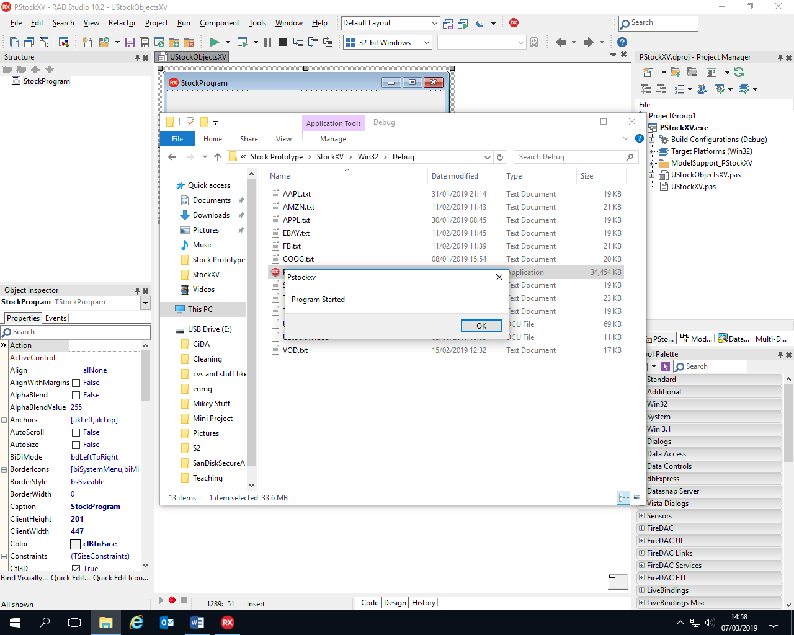

Figure 1

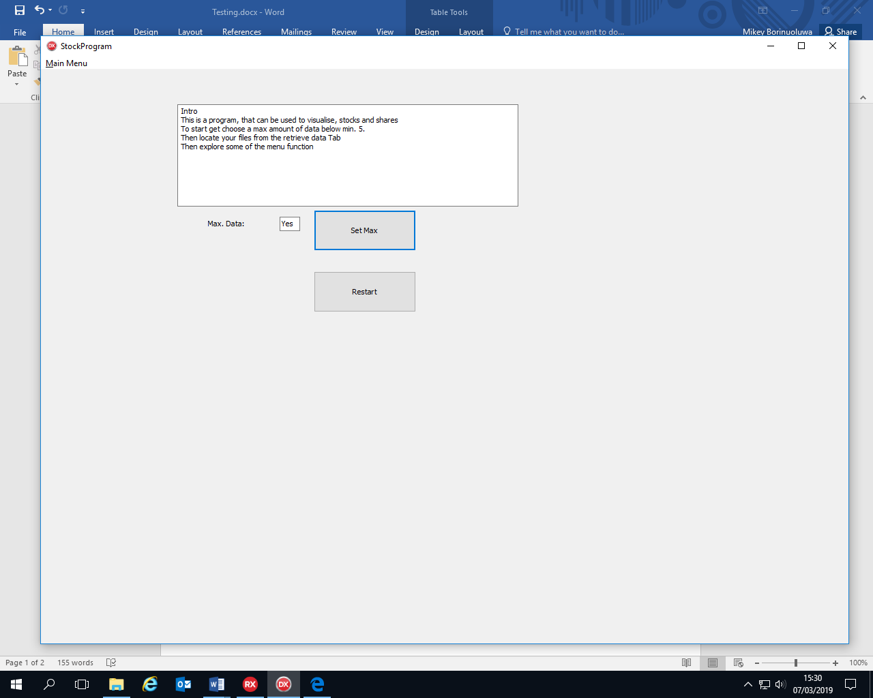

Figure 2

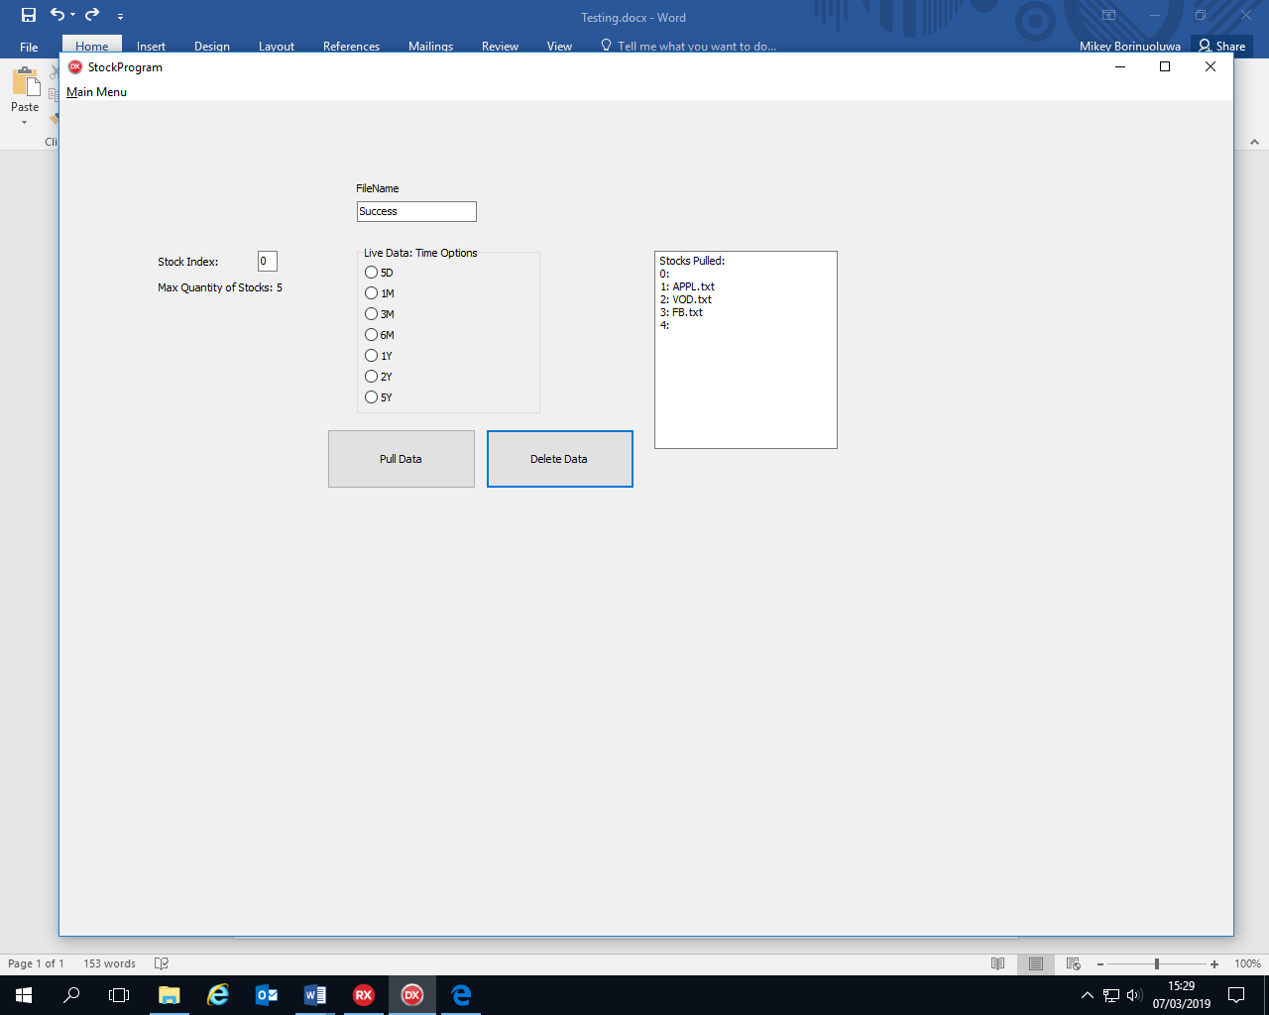

Figure 3

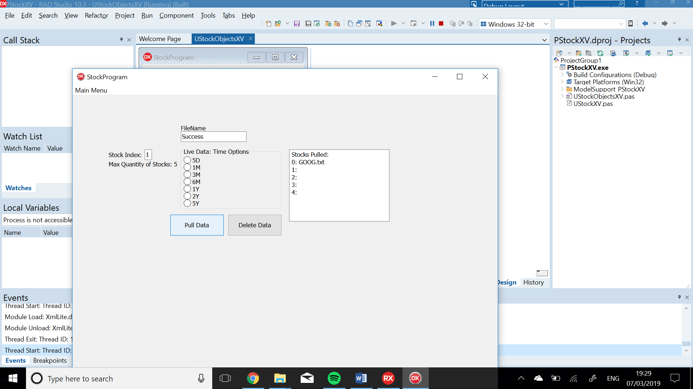

Figure 4

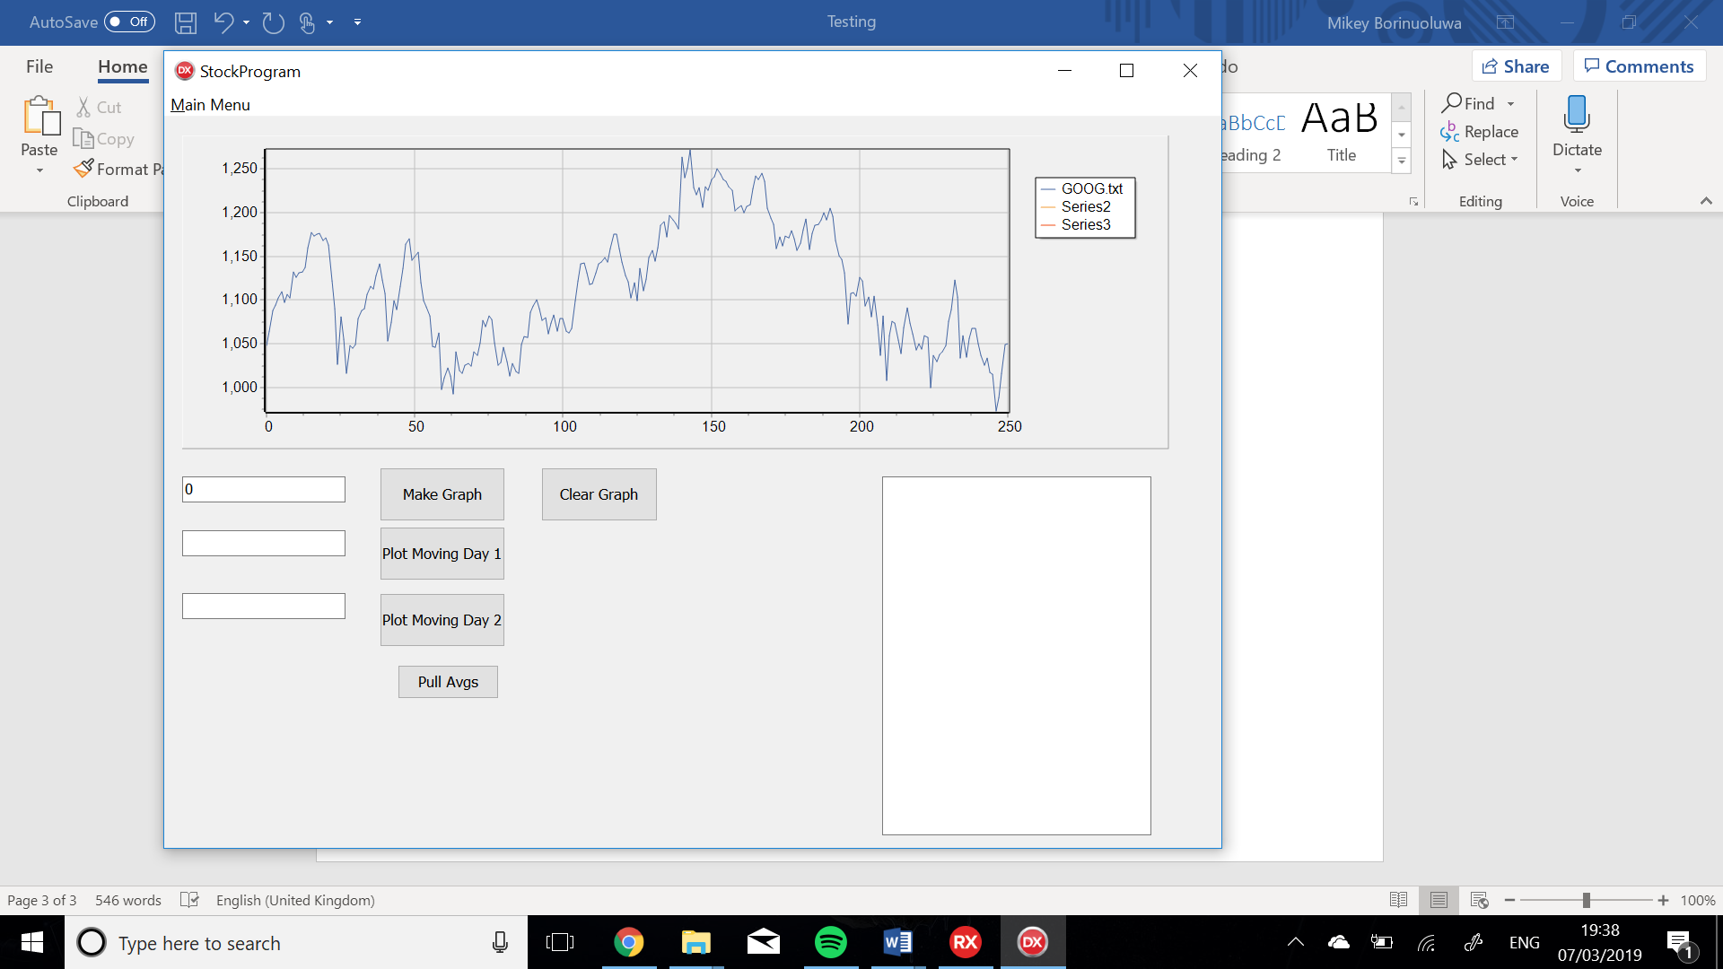

Figure 5

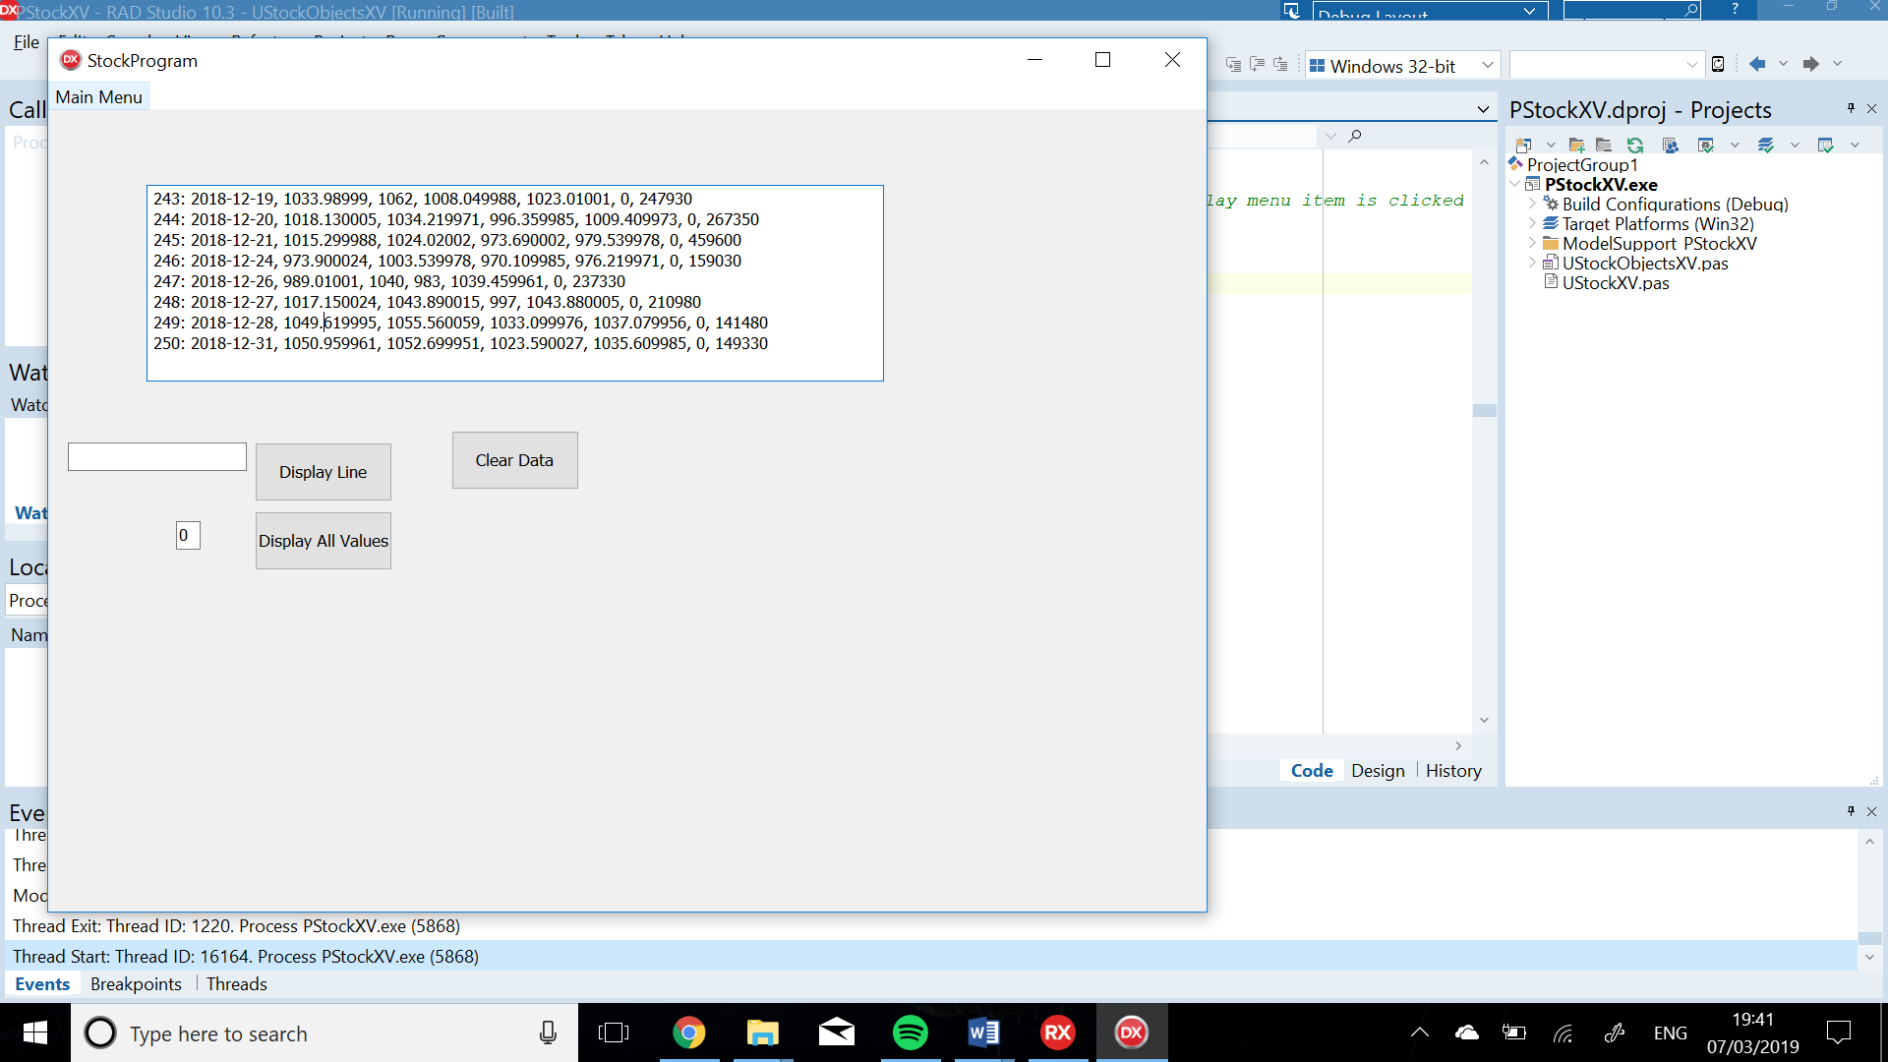

Figure 6

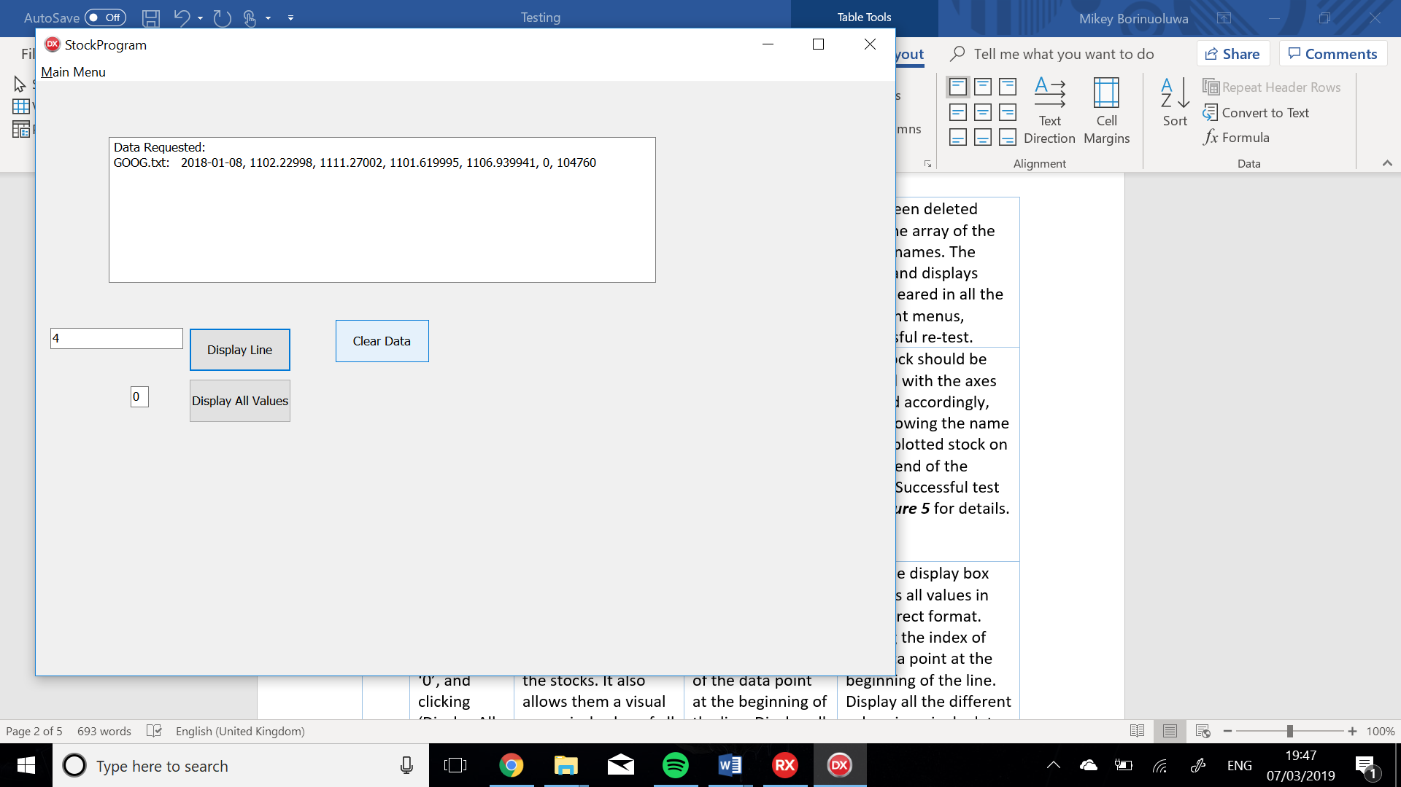

Figure 7

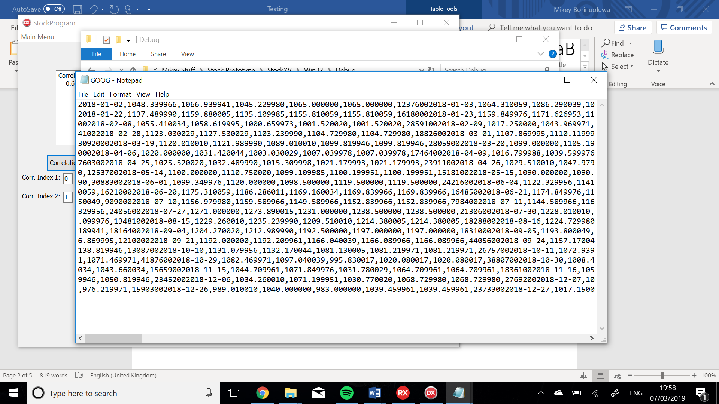

Figure 8

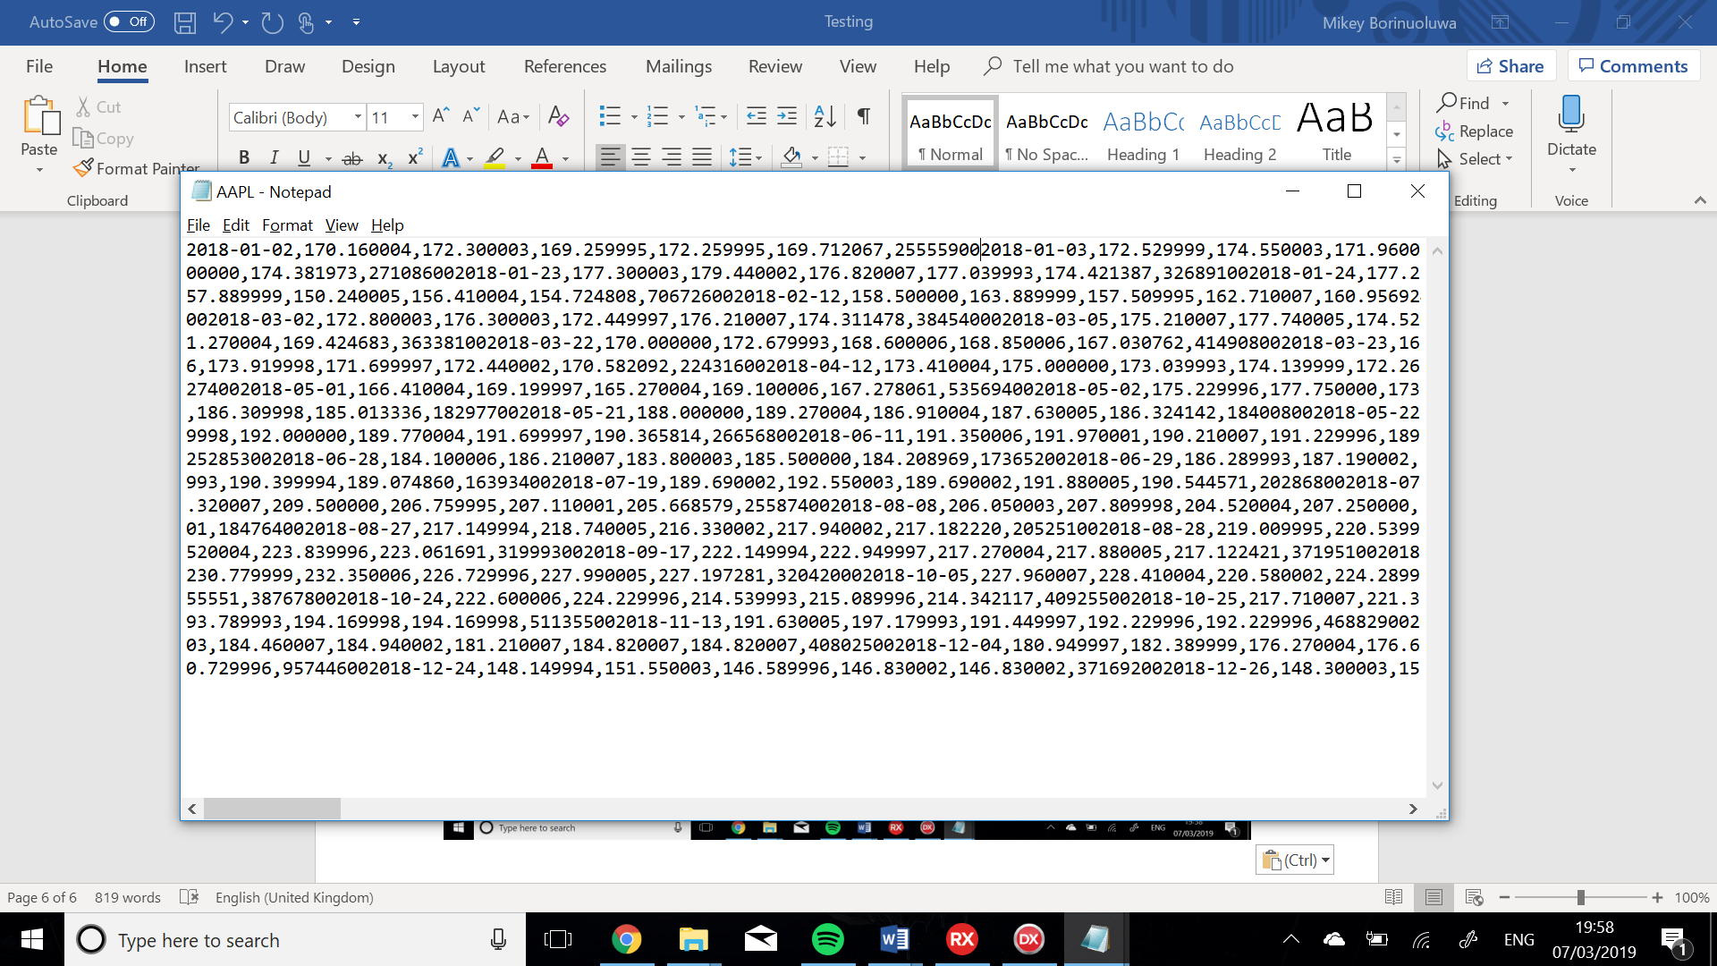

Figure 9

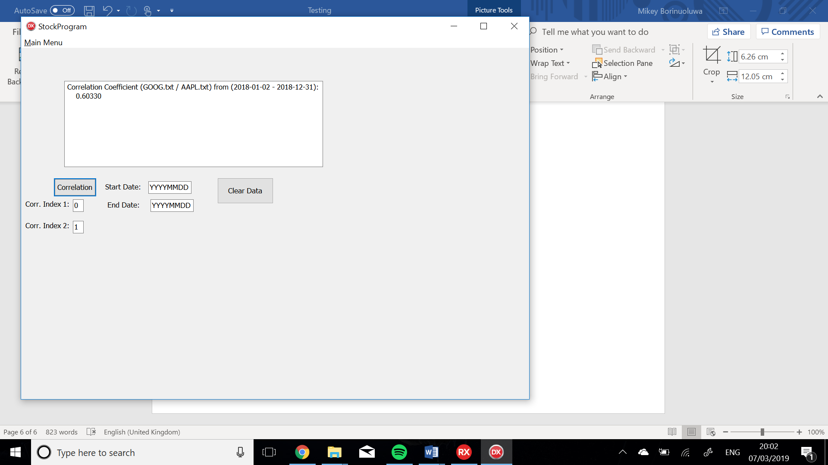

Figure 10

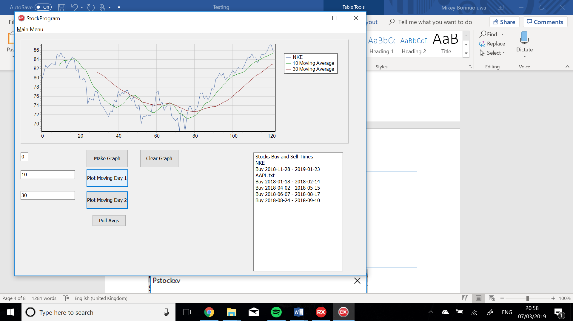

Figure 11

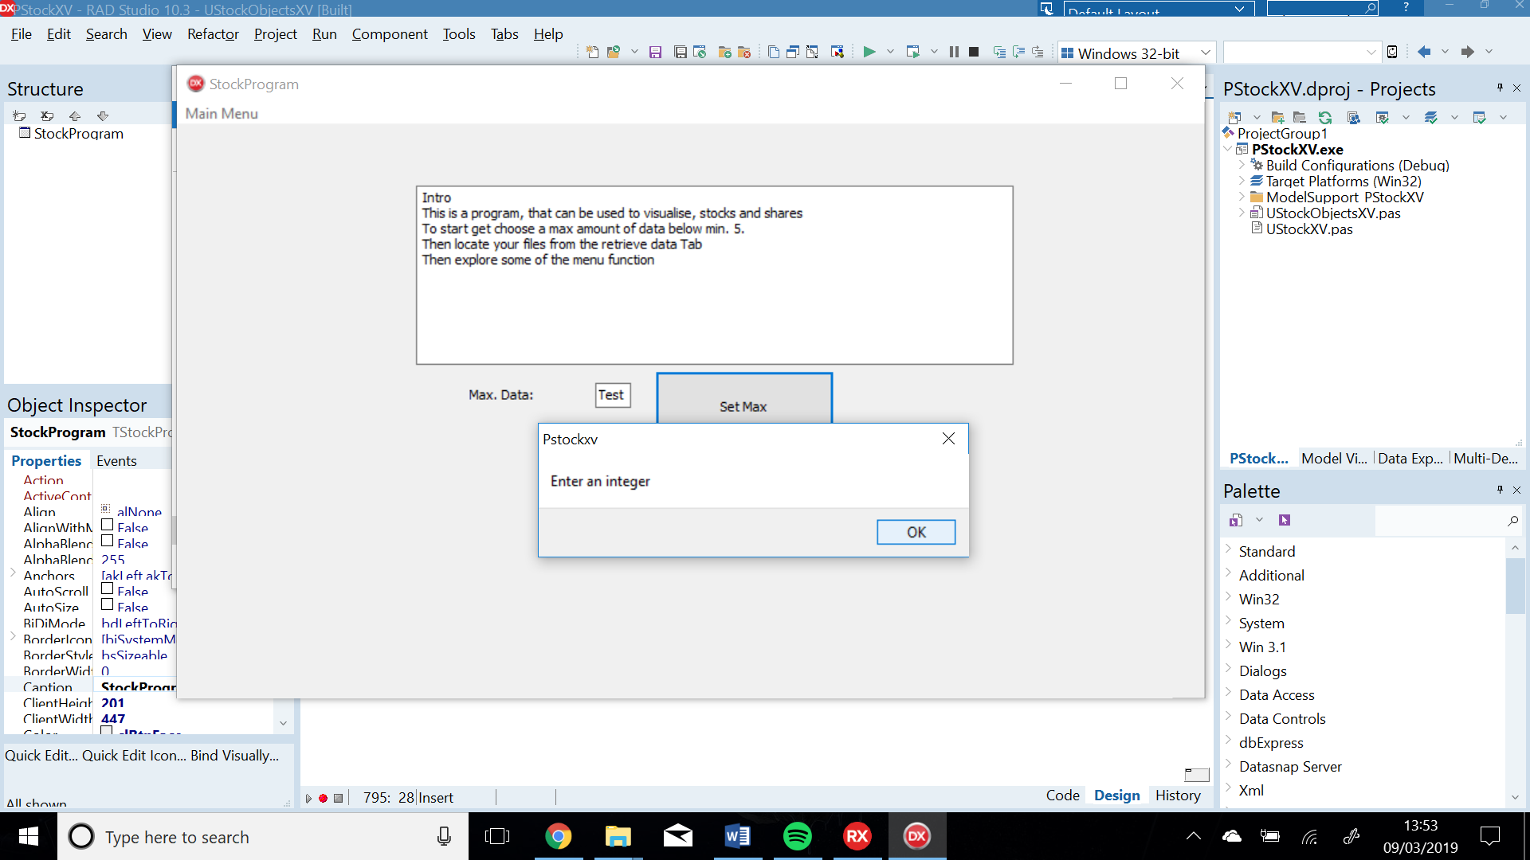

Figure

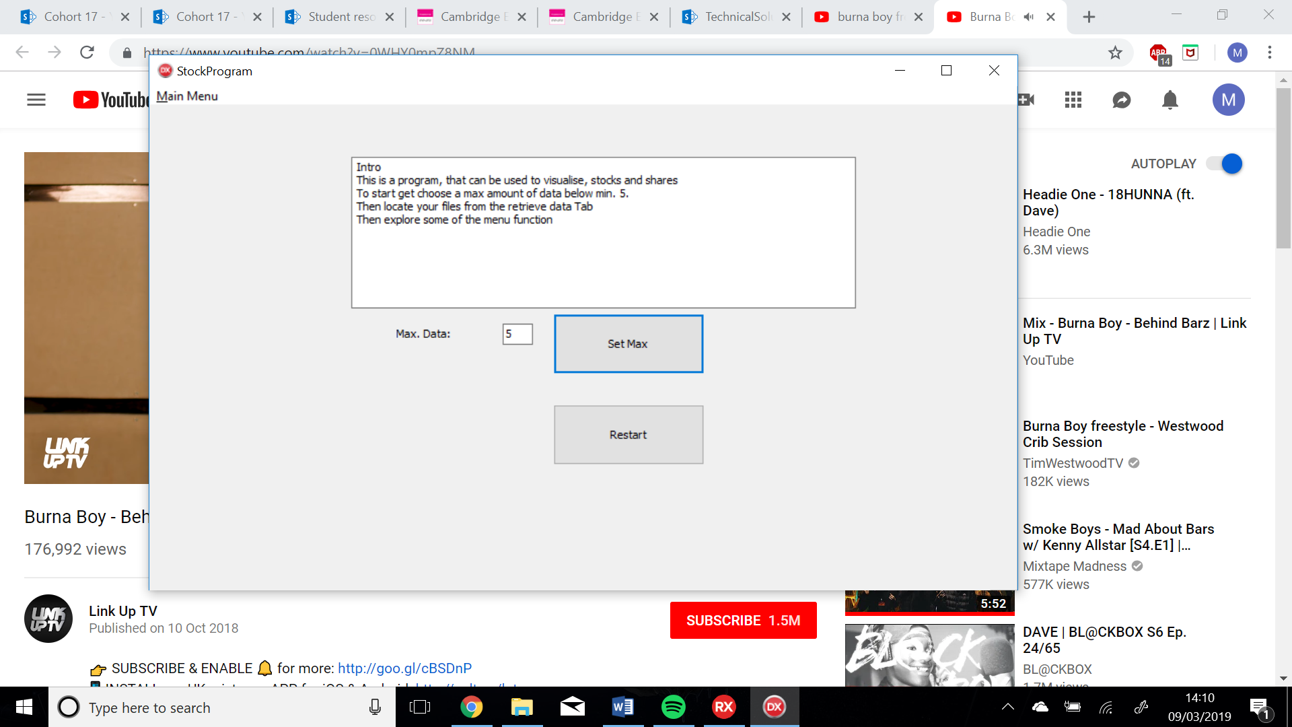

Figure

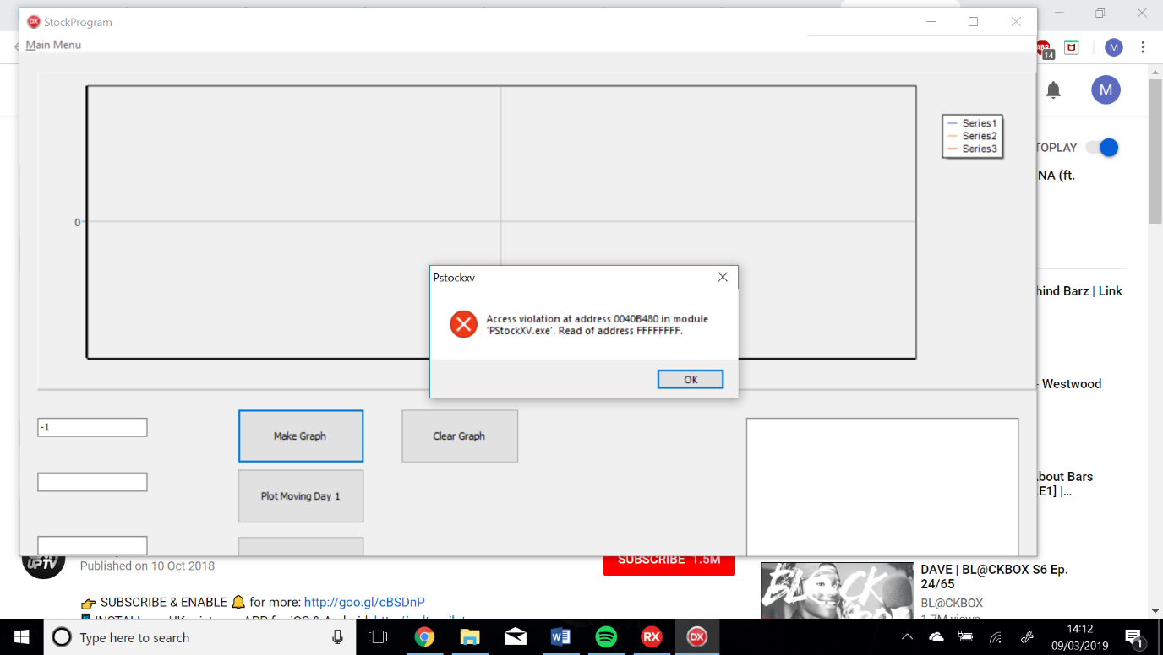

Figure

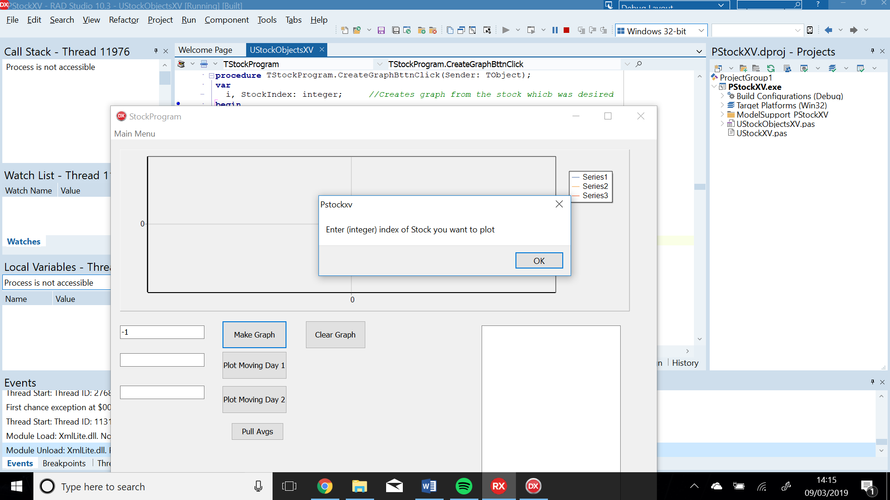

Figure

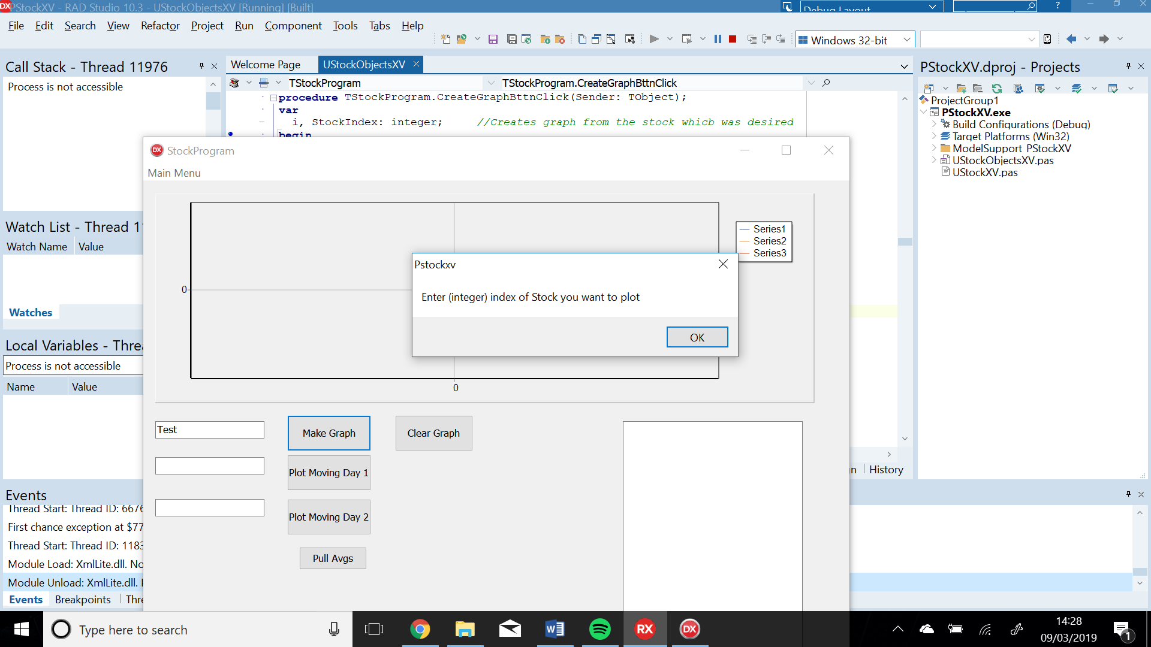

Figure

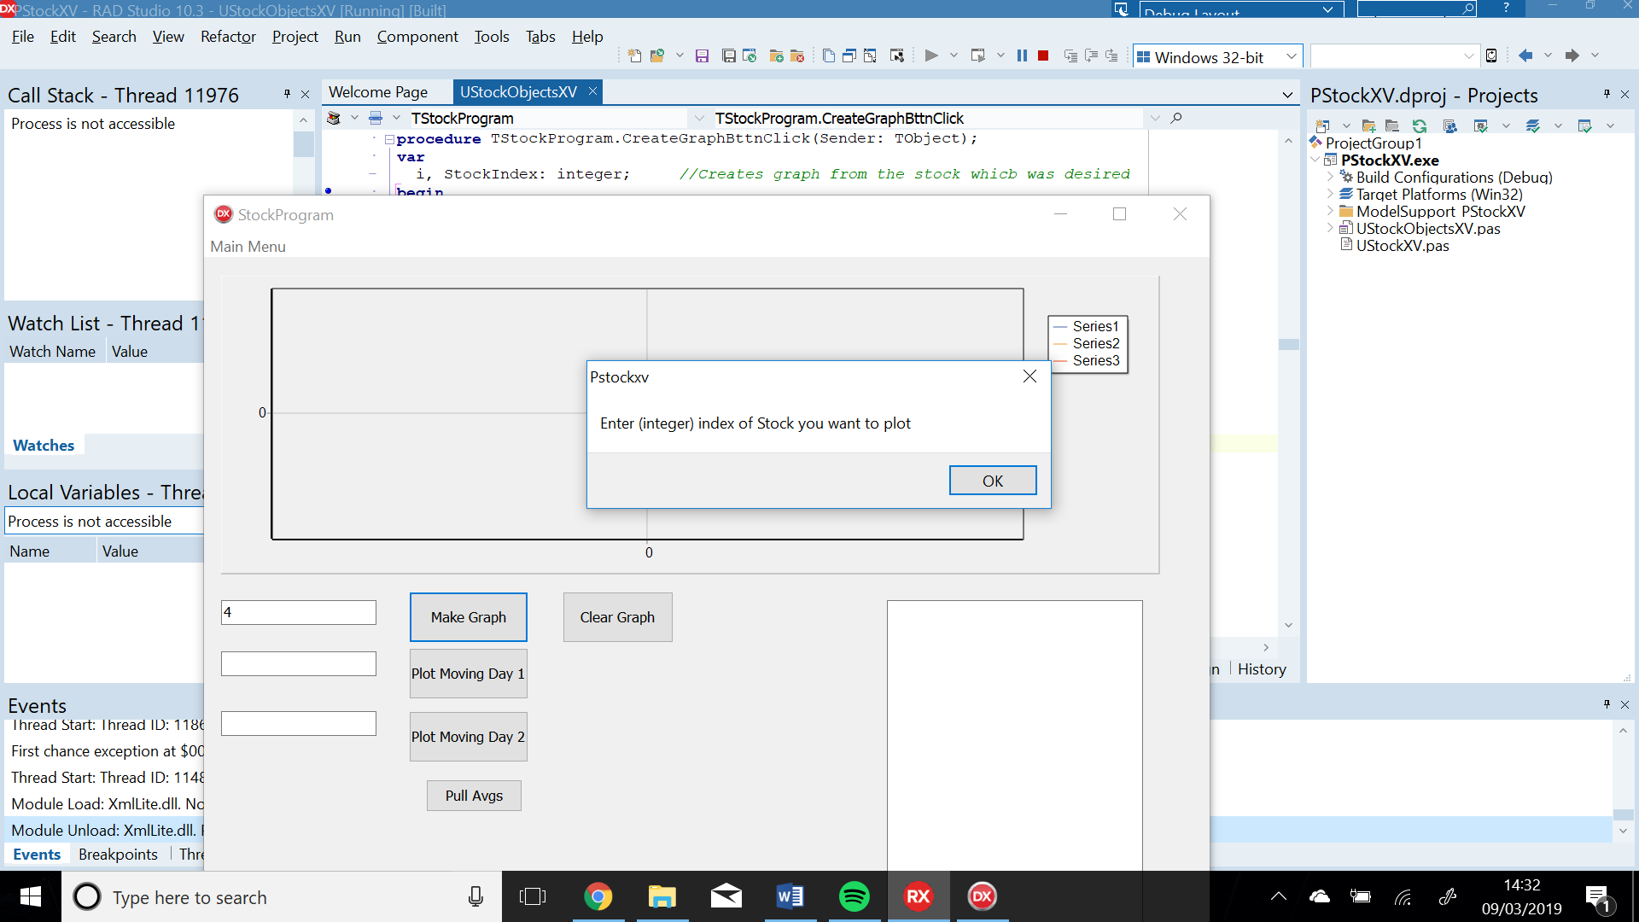

Figure

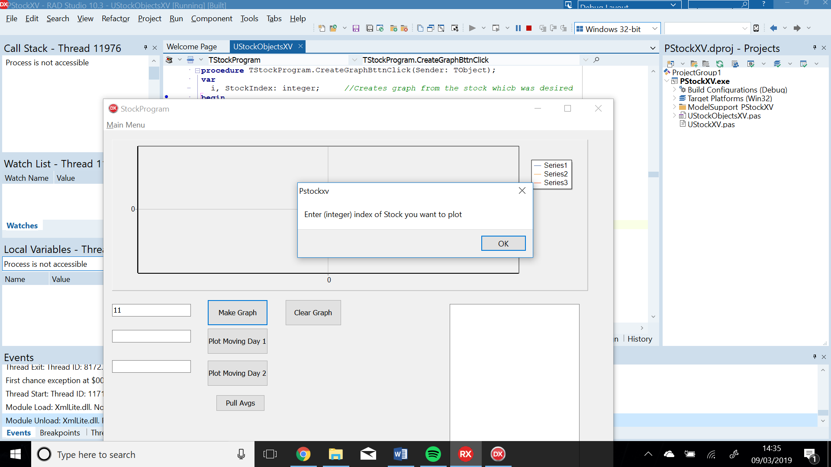

Figure

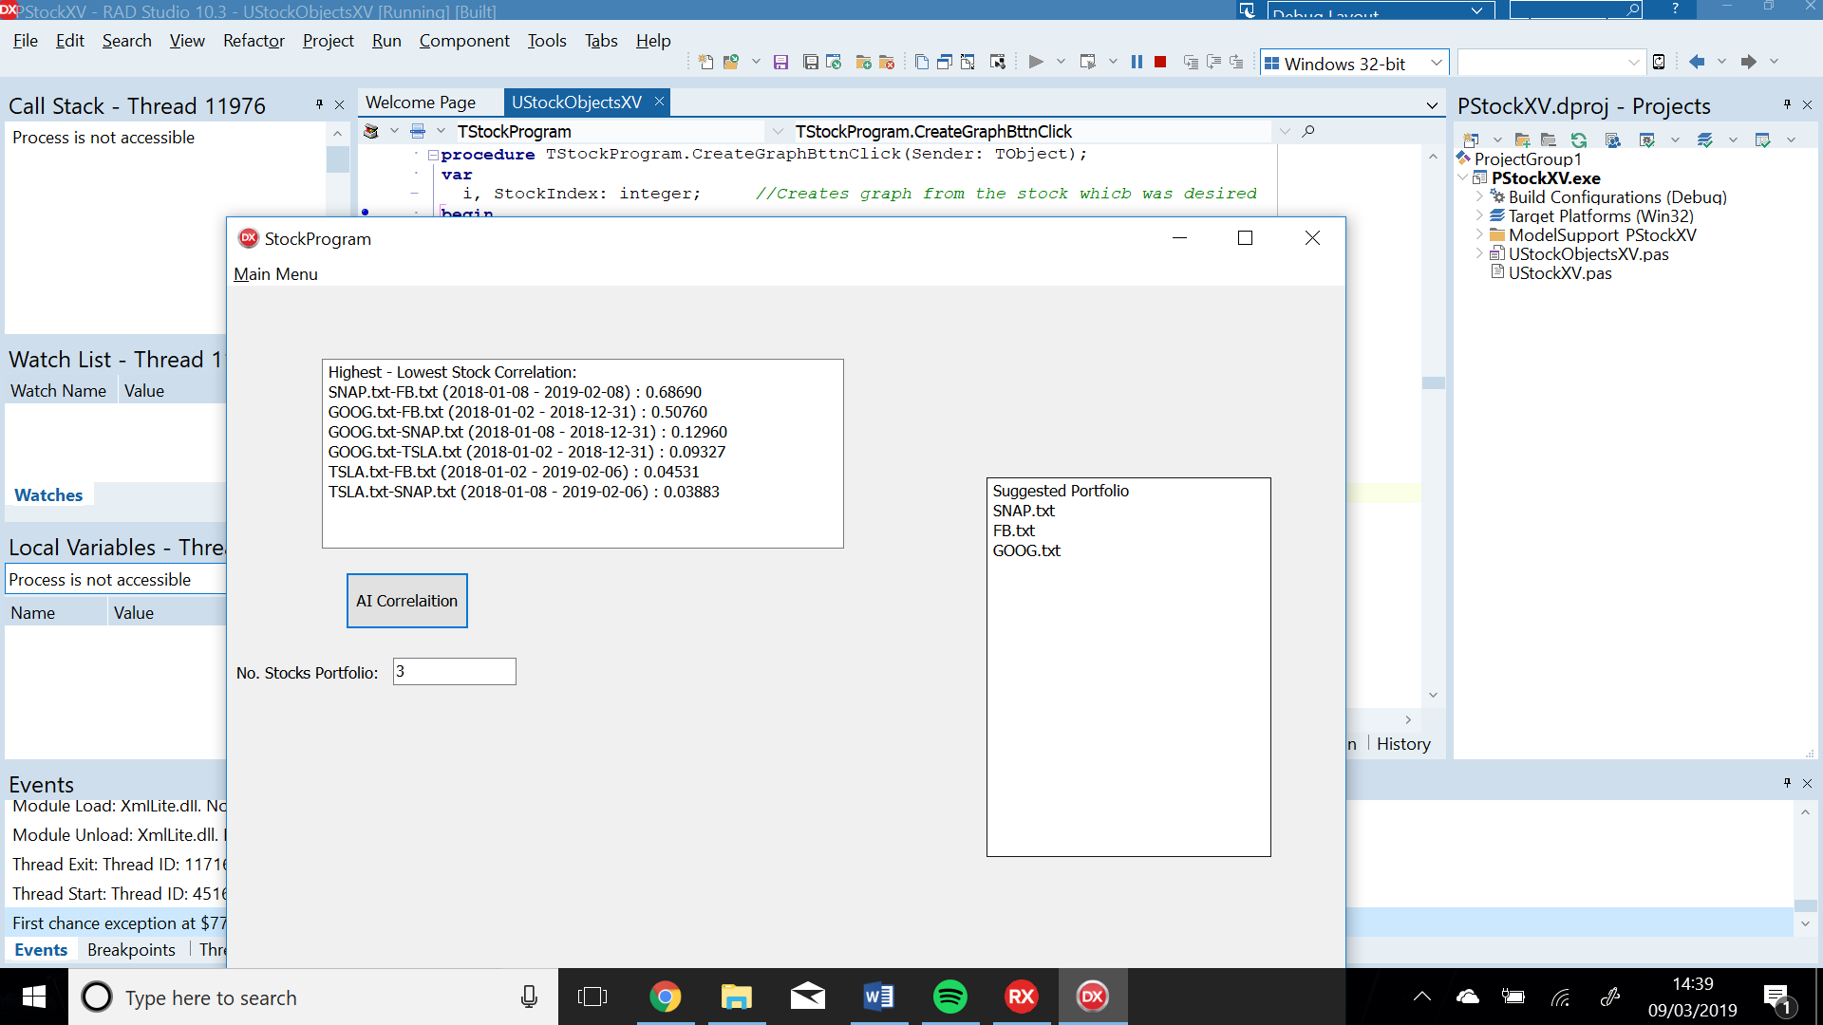

Figure

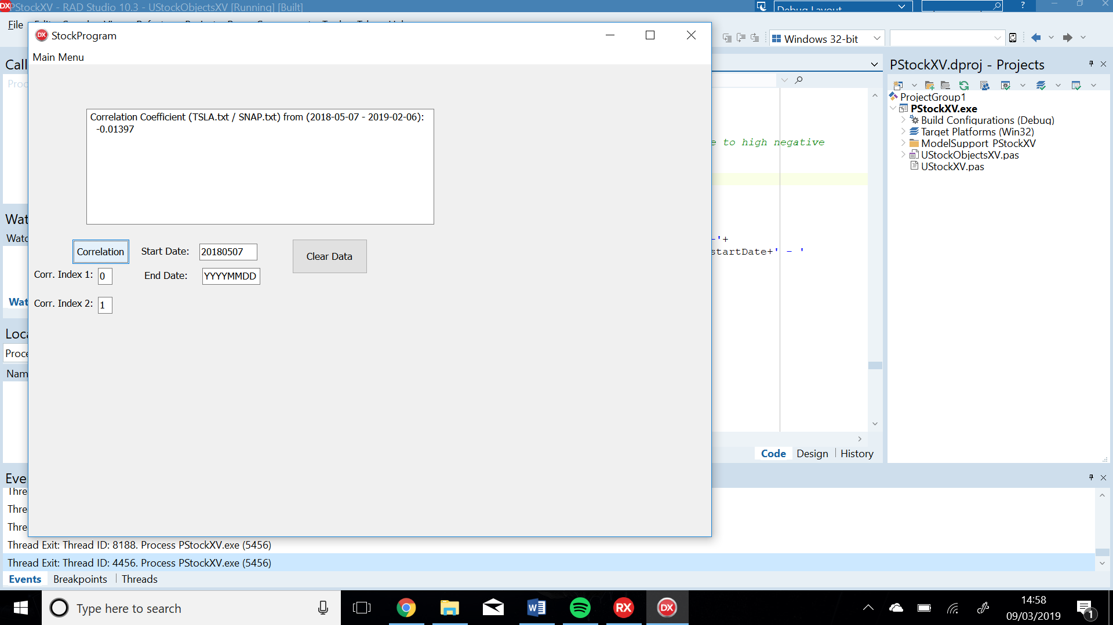

Figure

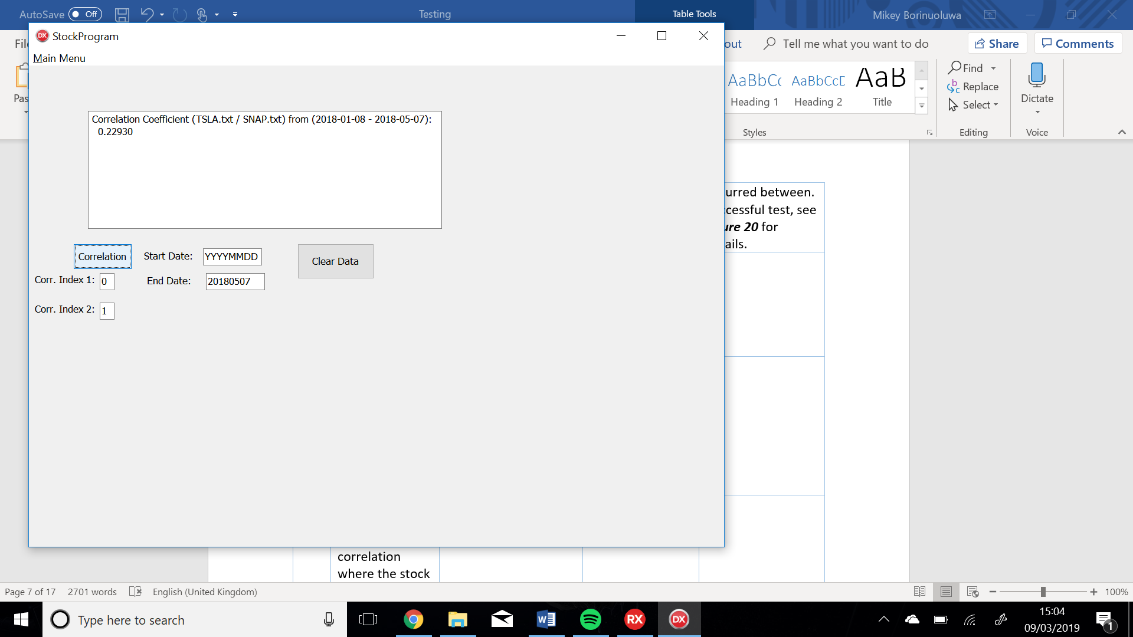

Figure

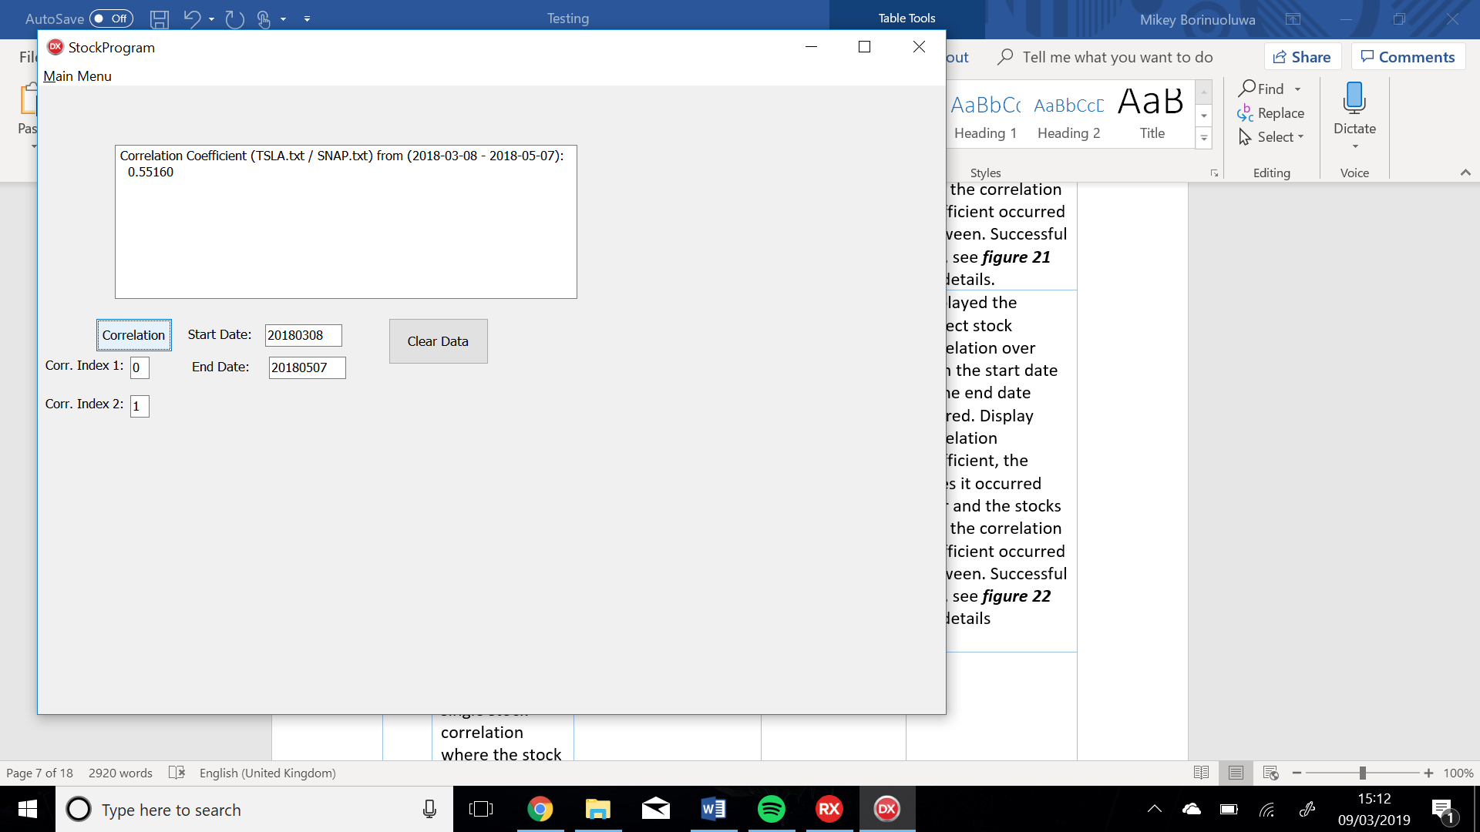

Figure

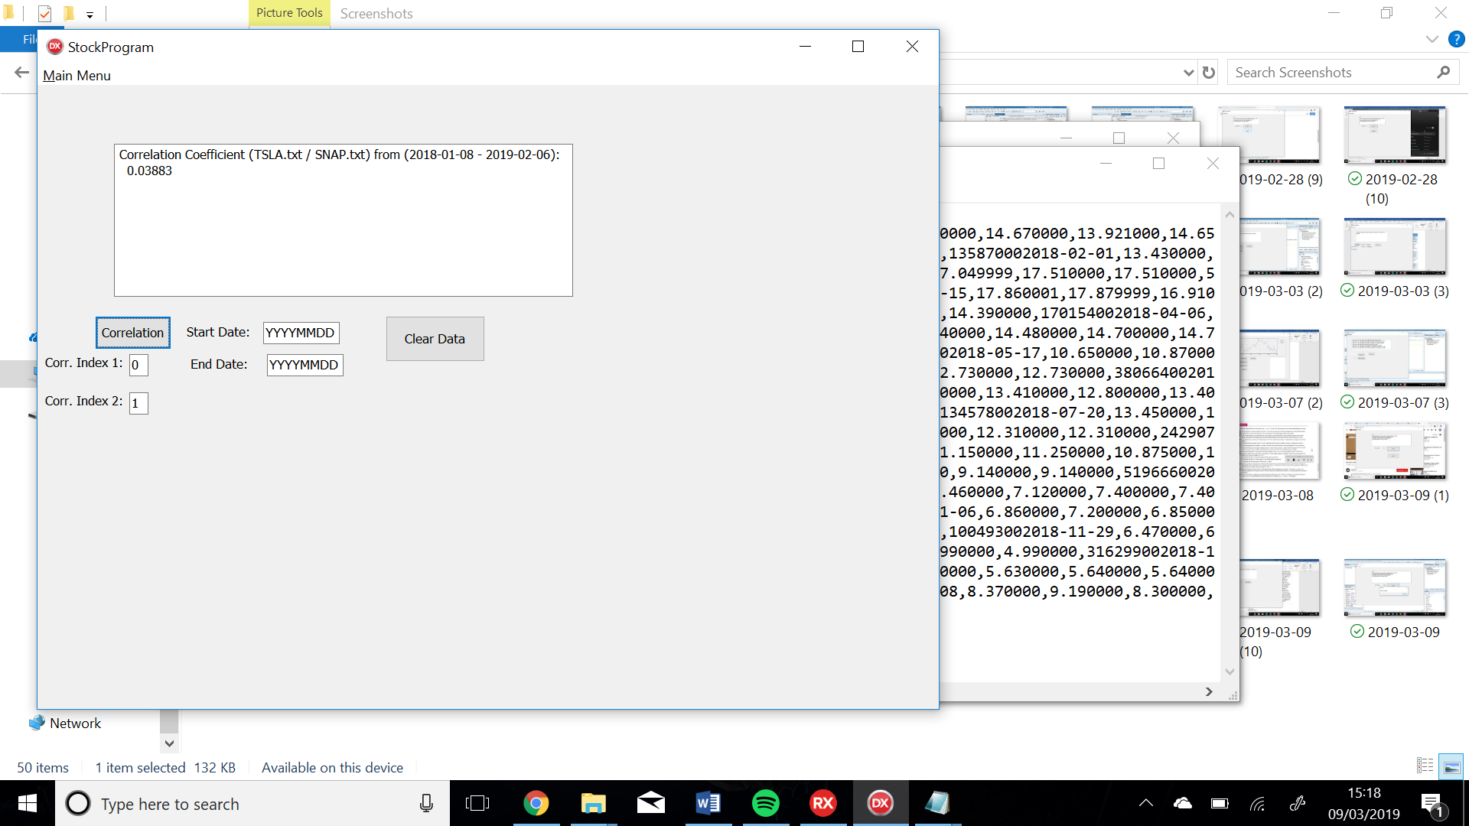

Figure

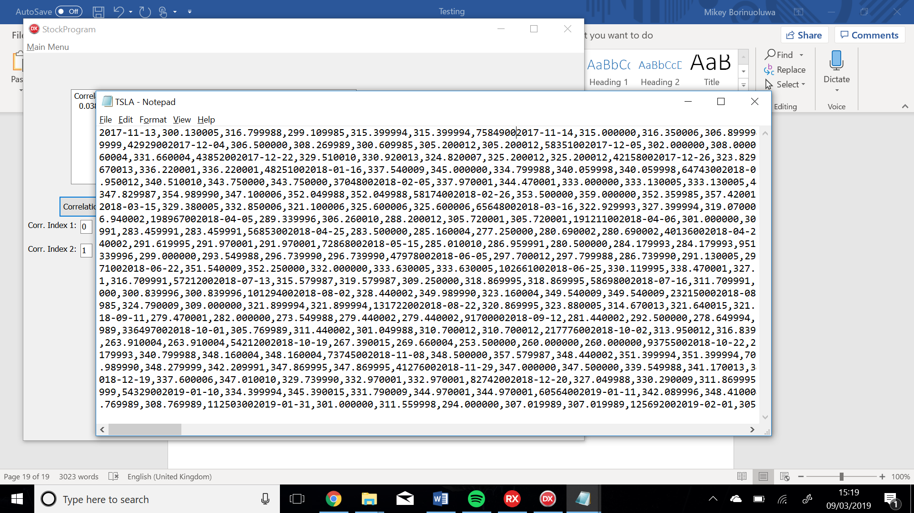

Figure

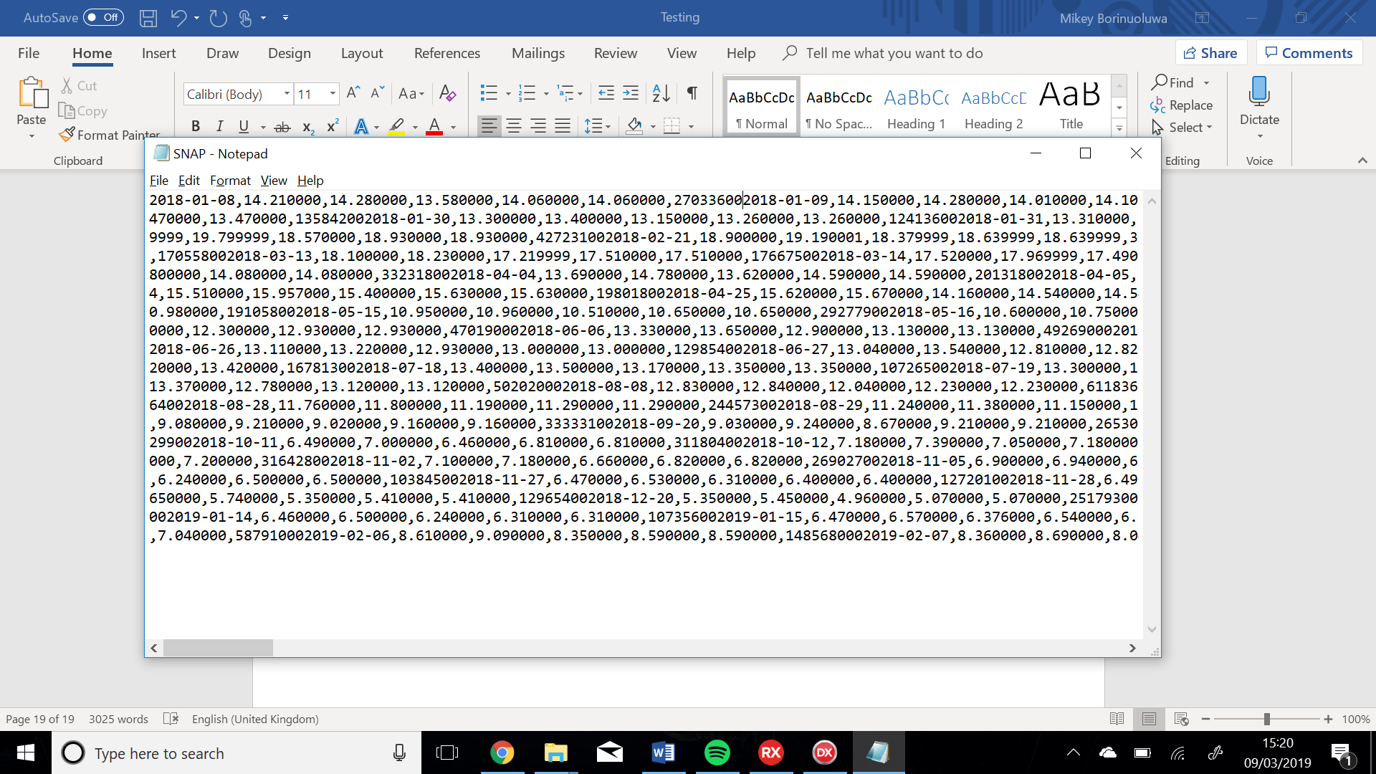

Figure

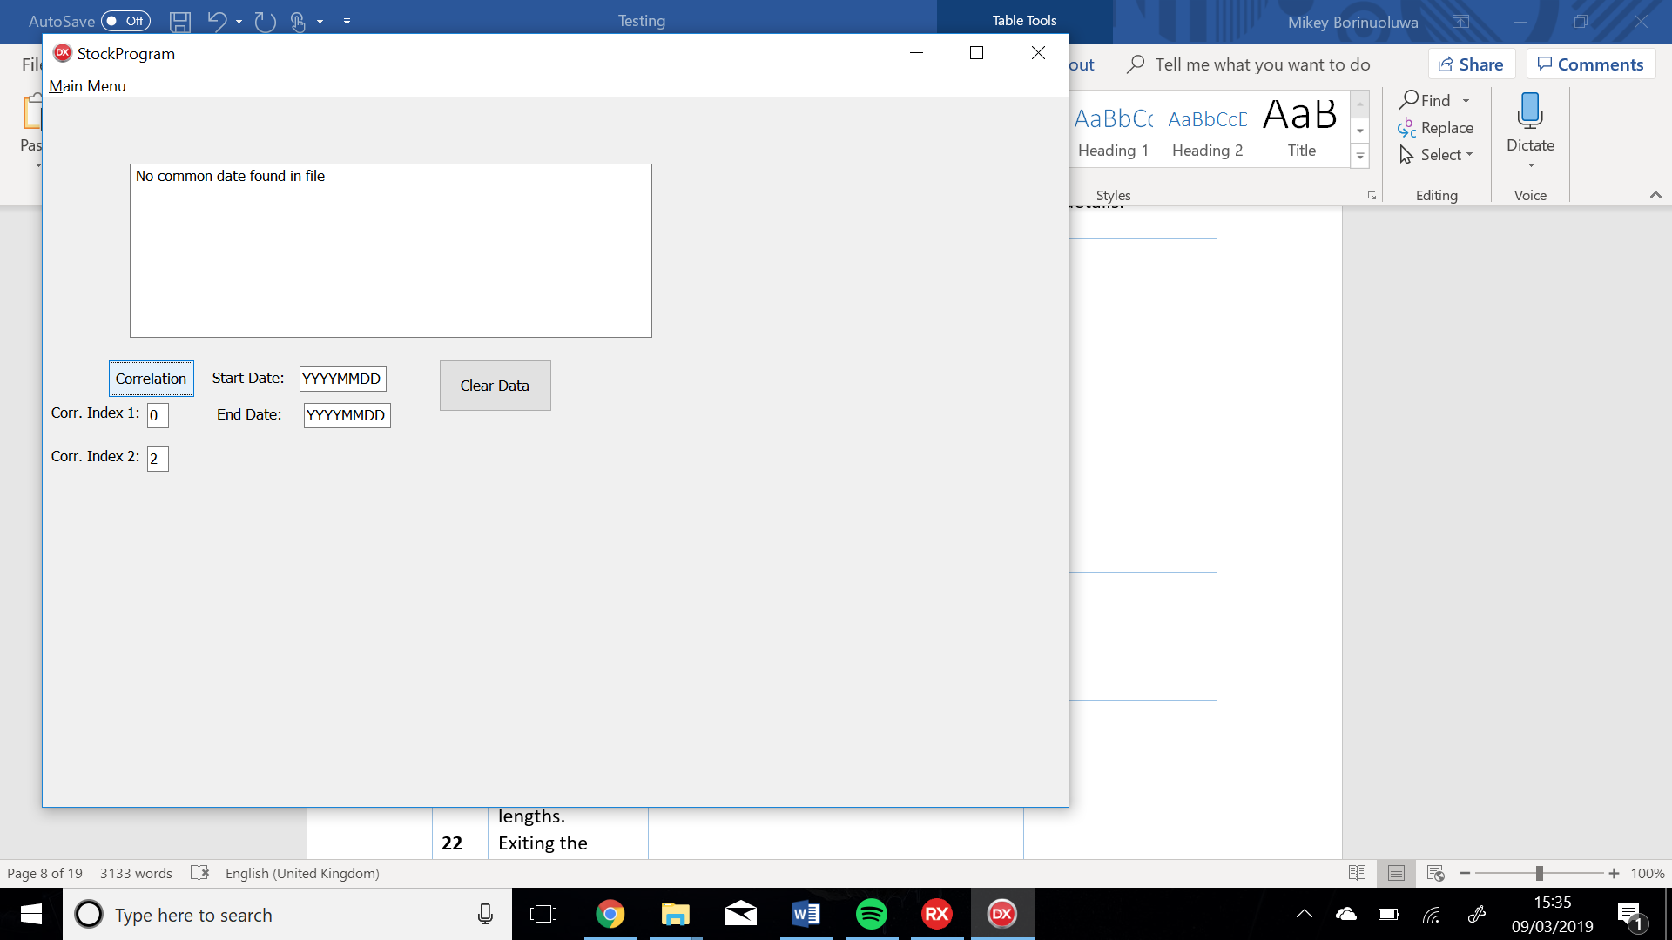

Figure

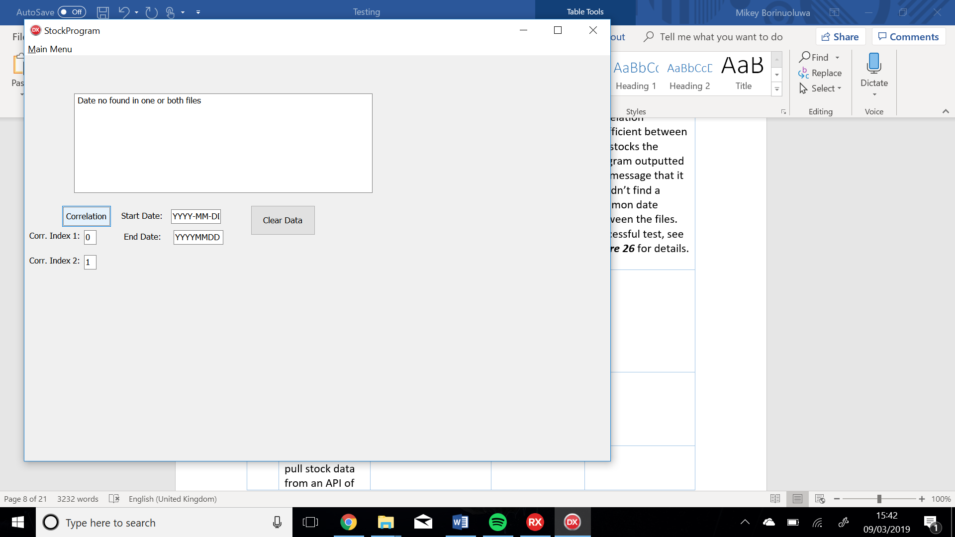

Figure

Figure

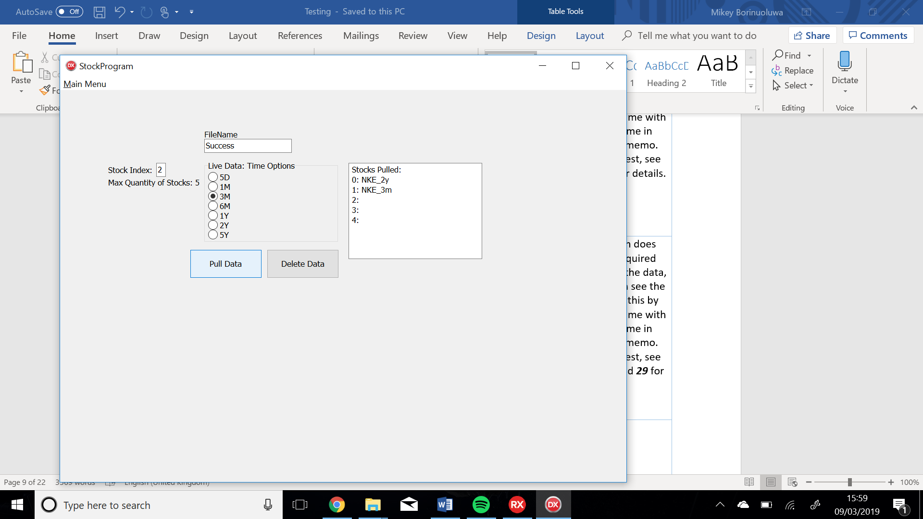

Figure